Website Portfolio Template

Asset Checklist
- Client Logo. Find their best logo to represent their business. Try not to choose black and white unless you have to.
- If Planter Package, get a screenshot the website we built and the URL
- If Planter Package, get the public link to brandbay
- If Planter Package, get the flat lay image from the graphic designer
- If any additional visuals, get the link and a photo/video
- Featured Image (See video)
- Headshot of the client for the testimonial
- Fun image next to the testimonial to represent the business

Content

UMFT
UMFT Clinic partnered with The Green House to build a stronger digital presence, modernize their brand identity, and increase client engagement. Through website optimization, paid media strategy, and improved reputation management, we enhanced their visibility and created a foundation for consistent lead generation and long-term growth.
Elements Included
- Lead Generation
- Website Development
- SEO
- Branding
- Reputation Management
Client Impact

About

UMFT Clinic delivers evidence-based, systems-oriented therapy designed to strengthen individuals, couples, and families. Alongside client care, the clinic trains future MFT clinicians through research-backed, ethical practices. With a focus on accessibility and reducing stigma, UMFT makes therapy a trusted resource for healthier lives and stronger communities.

Challenge
UMFT Clinic lacked a strong digital presence and cohesive brand identity. Their website was outdated and under-optimized for search, they had little visibility through paid media, and their reputation management tools were not being fully leveraged. These issues led to low lead generation and minimal client engagement.

Solution
- Developed a full brand package with logos, colors, typography, and guidelines.
- Designed a custom WordPress site with 10+ optimized, mobile-friendly pages.
- Executed Meta & Google paid media campaigns with targeting, creative, and optimization.
- Created a social media engagement plan aligned with client personas.
- Enhanced UMFT’s Google Business Profile with Q&A, photos, and posting.
- Built dashboards to track web, ad, and lead generation performance in real time.

Key Results
- Website & SEO: Optimized 10+ pages and mobile design, boosting search visibility.
- Reputation Management: Strengthened Google profile with updates, reviews, and content.
- Paid Media: Launched Meta & Google ads, driving higher traffic and leads.
- Lead Generation: Landing page testing increased conversions measurably.
- Brand Identity: Delivered a professional, unified brand across all channels.
Visual Showcase

Logo:
- Web Design: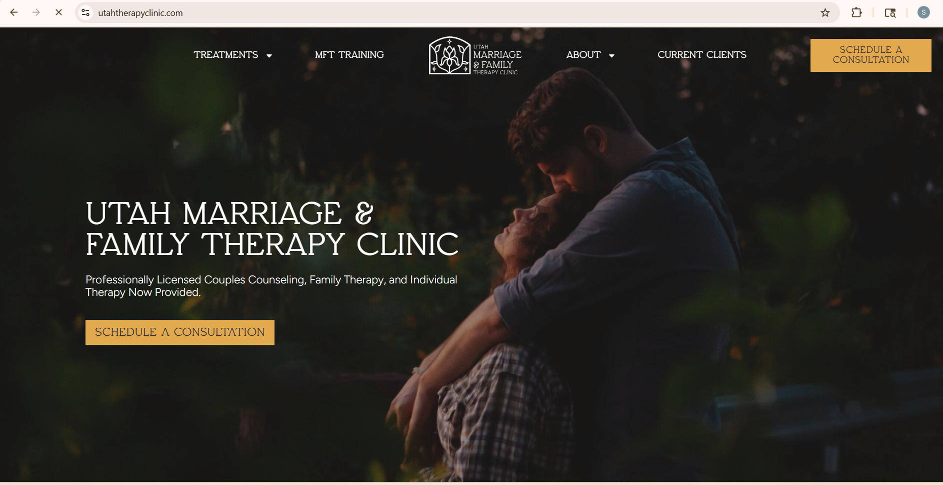
- TeamUMFT-103.jpg:
- BrandBay: https://app.brandbay.io/brand/umft
- Client headshot for testimonial UMFT-44.jpg:
Custom Planter Package
The Planter Package is our comprehensive branding and website development plan designed to help businesses establish strong digital roots. It combines brand identity, website development, SEO, social media, paid media, and reputation management to create a cohesive online presence that drives visibility and builds trust.

Student Impact
Est. Timeframe
6 Months
Est. Student Salaries
$5,850.00
Est. Time Spent
390 Hours

Testimonial
Green House supported us with our website, branding, and reputation management elements. The foundation they provided was truly great!
— Charles Mace, UMFT

